 NARROGIN SENIOR HIGH SCHOOL

English Foundation Year 11 (FEENG)

Student: Teacher: McWilliams Date Due: 11/09/2020

Assessment Type: Short Story Composition

Task 8: Writing

You are to write a short story of no more than 2 pages based on one of the image prompts provided. You must hand in the notes, the draft and the final copy of the short story.

Part One:
Choose one of the image prompts provided and complete the notes on your short story. (20%)

Part Two:
Write a draft of your imaginative short story of between 300 and 600 words (maximum of two pages). (20%)

Part Three:
Write final copy of your imaginative short story of between 300 and 600 words (maximum of two pages). (60%)

Time allocation: 6 periods
Conditions: in-class
Weighting: 10%

Mark: / 100

To be assessed for this task you must submit: | Date Due | YES | NO
Notes/plan of your short story | 11/09/2020
Draft of your short story | 11/09/2020
Final Copy of your short story | 11/09/2020

Teacher Comment:

Self-reflection
What three things did I do well?
What three things could I have done better?
What things could I do in class to help me improve for the next task?
What things could I do at home to help me improve for the next task?

PART ONE


PLAN your NARRATIVE

Characters: Major character’s name:

Minor character’s name:

Setting: Where:

When:

Conflict: Main problem


PLAN your NARRATIVE

Characters: Major character’s name:

Minor character’s name:

Setting: Where:

When:

Conflict: Main problem


PLAN your NARRATIVE

Characters: Major character’s name:

Minor character’s name:

Setting: Where:

When:

Conflict: Main problem


PLAN your NARRATIVE

Characters: Major character’s name:

Minor character’s name:

Setting: Where:

When:

Conflict: Main problem

NAME:

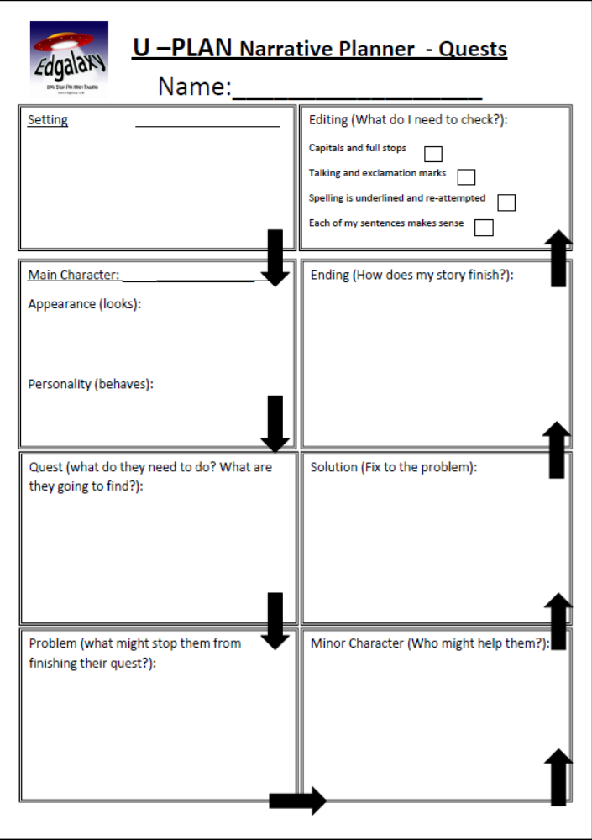

PART TWO

Using the information you have written in Part One, write a draft of your short story:

PART THREE

Attach your final copy (either written or typed) here:

Criteria | The Response | Marks
Part One
Meeting the requirements of the task | Addresses all aspects of the task, providing relevant detail where required | 8-10
Meeting the requirements of the task | Addresses most aspects of the task, providing detail where required | 6-7
Meeting the requirements of the task | Addresses some aspects of the task, at times providing detail | 5
Meeting the requirements of the task | Addresses very few aspects of the task, rarely providing detail | 3-4
Meeting the requirements of the task | Does not meet the requirements of a D grade and/or has completed insufficient assessment tasks to be assigned a higher grade. | 0-2
Mechanics of grammar, spelling and punctuation | Controls the mechanics of grammar, spelling and punctuation | 5
Mechanics of grammar, spelling and punctuation | Controls most of the mechanics of grammar, spelling and punctuation | 4
Mechanics of grammar, spelling and punctuation | Controls some of the mechanics of grammar, spelling and punctuation | 3
Mechanics of grammar, spelling and punctuation | Controls very few of the mechanics of grammar, spelling and punctuation | 2
Mechanics of grammar, spelling and punctuation | Does not meet the requirements of a D grade and/or has completed insufficient assessment tasks to be assigned a higher grade. | 1
Purpose, audience, genre/form | Discusses purpose, audience and genre/form | 5
Purpose, audience, genre/form | Comments on the purpose, audience and/or genre/form | 4
Purpose, audience, genre/form | Refers to the purpose, audience and/or genre/form | 3
Purpose, audience, genre/form | Rarely refers to the purpose, audience and/or genre/form | 2
Purpose, audience, genre/form | Does not meet the requirements of a D grade and/or has completed insufficient assessment tasks to be assigned a higher grade. | 1
 | Total for Part One | /20
Part Two
Language and expression | Usually controls vocabulary and language features for clarity of expression, development of voice and awareness of audience | 8-10
Language and expression | Often controls vocabulary and language features for clarity of expression, development of voice and awareness of audience | 6-7
Language and expression | Sometimes controls vocabulary and language features for clarity of expression and awareness of audience | 5
Language and expression | Rarely controls vocabulary and language features for clarity of expression and awareness of audience | 3-4
Language and expression | Does not meet the requirements of a D grade and/or has completed insufficient assessment tasks to be assigned a higher grade. | 0-2
Structure | Organises ideas in an effective structure at sentence, paragraph and whole text level | 5
Structure | Usually organises ideas in an appropriate structure at sentence, paragraph and whole text level | 4
Structure | Sometimes organises ideas at sentence, paragraph and whole text level | 3
Structure | Rarely organises ideas at sentence, paragraph and whole text level | 2
Structure | Does not meet the requirements of a D grade and/or has completed insufficient assessment tasks to be assigned a higher grade. | 1
Mechanics of grammar, spelling and punctuation | Controls the mechanics of grammar, spelling and punctuation | 5
Mechanics of grammar, spelling and punctuation | Controls most of the mechanics of grammar, spelling and punctuation | 4
Mechanics of grammar, spelling and punctuation | Controls some of the mechanics of grammar, spelling and punctuation | 3
Mechanics of grammar, spelling and punctuation | Controls very few of the mechanics of grammar, spelling and punctuation | 2
Mechanics of grammar, spelling and punctuation | Does not meet the requirements of a D grade and/or has completed insufficient assessment tasks to be assigned a higher grade. | 1
 | Total for Part Two | /20
Part Three
Language and expression | Usually controls vocabulary and language features for clarity of expression, development of voice and awareness of audience | 16-20
Language and expression | Often controls vocabulary and language features for clarity of expression, development of voice and awareness of audience | 13-15
Language and expression | Sometimes controls vocabulary and language features for clarity of expression and awareness of audience | 10-12
Language and expression | Rarely controls vocabulary and language features for clarity of expression and awareness of audience | 6-10
Language and expression | Does not meet the requirements of a D grade and/or has completed insufficient assessment tasks to be assigned a higher grade. | 0-6
Purpose, audience, genre/form | Adheres consistently to the conventions of the genre as modelled | 16-20
Purpose, audience, genre/form | Adheres to most of the conventions of the genre as modelled | 13-15
Purpose, audience, genre/form | Adheres to some of the conventions of the genre as modelled ensuring that the genre is recognisable | 10-12
Purpose, audience, genre/form | Adheres to very few of the conventions of the genre as modelled | 6-10
Purpose, audience, genre/form | Does not meet the requirements of a D grade and/or has completed insufficient assessment tasks to be assigned a higher grade. | 0-6
Structure | Organises ideas in an effective structure at sentence, paragraph and whole text level | 8-10
Structure | Usually organises ideas in an appropriate structure at sentence, paragraph and whole text level | 6-7
Structure | Sometimes organises ideas at sentence, paragraph and whole text level | 5
Structure | Rarely organises ideas at sentence, paragraph and whole text level | 3-4
Structure | Does not meet the requirements of a D grade and/or has completed insufficient assessment tasks to be assigned a higher grade. | 0-2
Mechanics of grammar, spelling and punctuation | Controls the mechanics of grammar, spelling and punctuation | 8-10
Mechanics of grammar, spelling and punctuation | Controls most of the mechanics of grammar, spelling and punctuation | 6-7
Mechanics of grammar, spelling and punctuation | Controls some of the mechanics of grammar, spelling and punctuation | 5
Mechanics of grammar, spelling and punctuation | Controls very few of the mechanics of grammar, spelling and punctuation | 3-4
Mechanics of grammar, spelling and punctuation | Does not meet the requirements of a D grade and/or has completed insufficient assessment tasks to be assigned a higher grade. | 0-2
 | Total for Part Three | /60
 | Total | /100

